Manual Zomby Wars
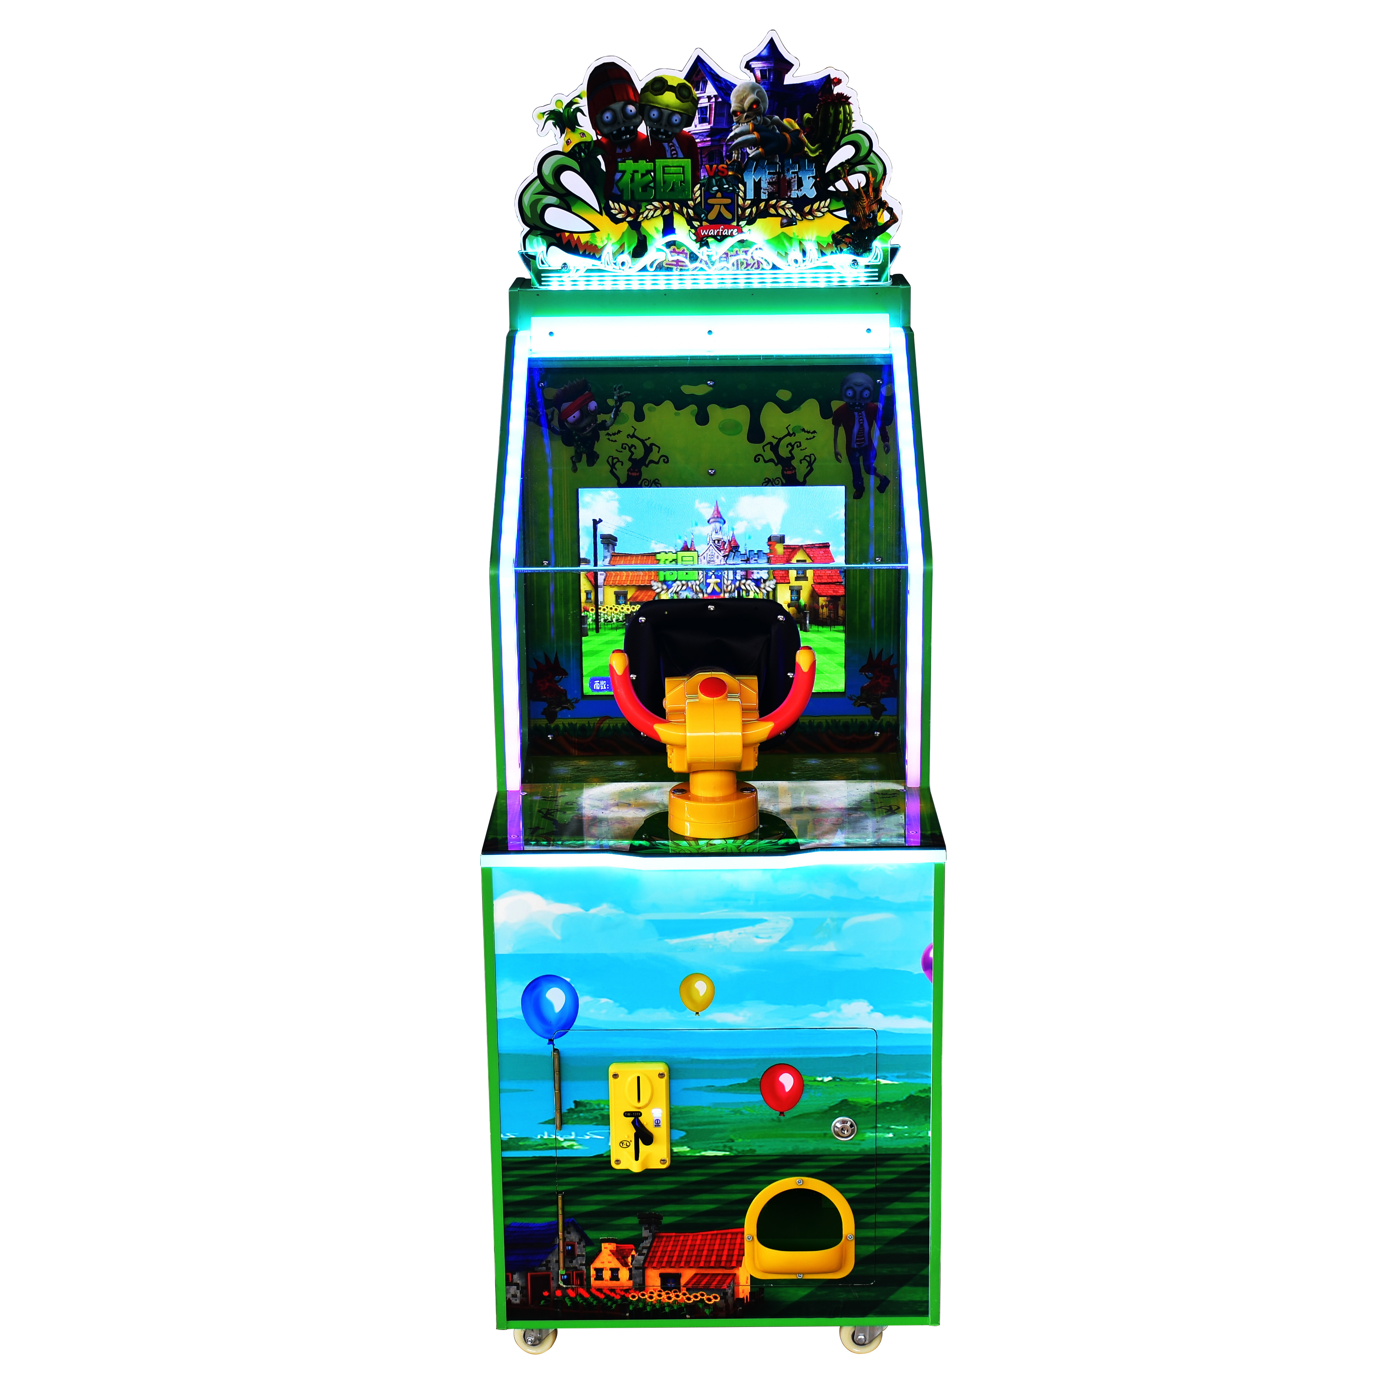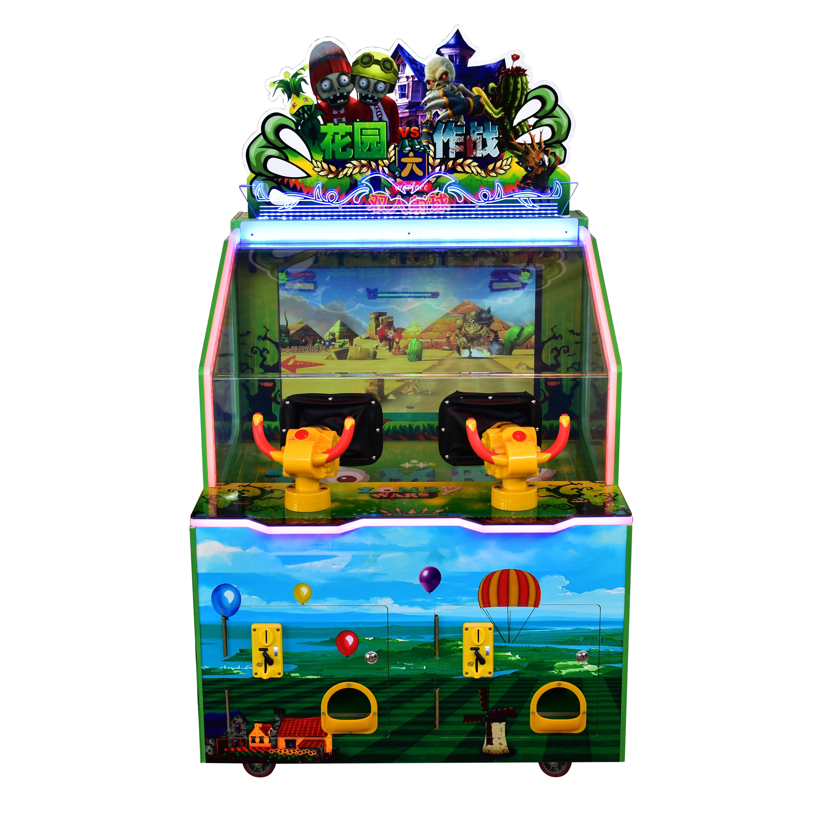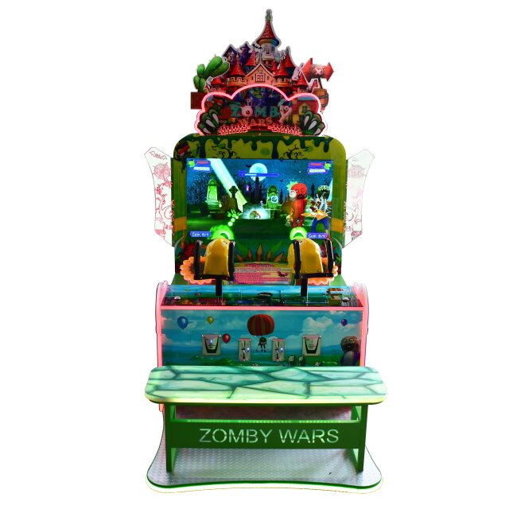
Parameter Index
Name | Zomby Wars
Material | Metal,wood，Acrylic
Type | Coin operated game machine
Voltage | 100-200W
Size | 17”1P ball shooting;32”2P ball shooting;42” 2p gun shooting
Suitable age | Over 7 years of age
Map | 4
Game Prize | Capsule toys or Ticket

How to play the game
Play Instruction
1.Press start button,shoot the gun target to select the level
2.Destroy the zombies during game limited time to pass the next level
3.Game over, win tickets or gift.
Options Description
- Press the "setting " button to enter the options interface.
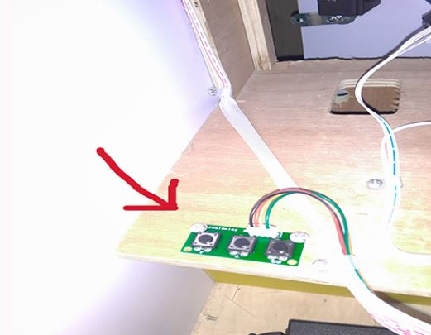
- In options interface,move the cursor up and down to choose the option and move left and right to adjust the value.Finally,press the ok button to exit.
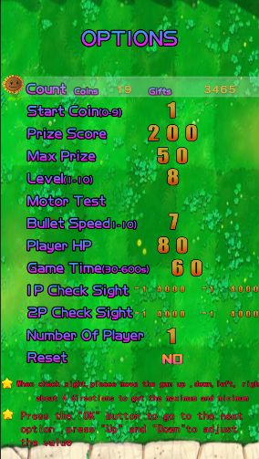
3.Options
Count coins：show the number of coins and toys won
Start Coin：How many coins to play a game
Prize Score：How many score can get one prize
Max Prize: Set the maximum prize value
Level：Set the game difficulty
Motor Test：Test the toy machine
Bullet Speed：Set the speed of gun bullet in game
Player Hp：Set the life value of player
Game Time：Set the game time
1P Check Sight：Check the machine gun 1P adjust (muzzle battle screen, respectively, up and down around 4 directions to obtain 4 azimuths)
2P Check Sight：Check the machine gun 2 (muzzle battle screen, respectively, up and down around 4 directions to obtain 4 azimuths)
Number Of Player：How many player can play
Reset：Reset your Options
Game Interface
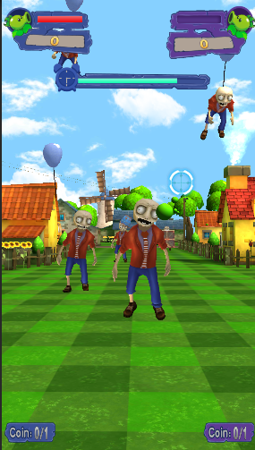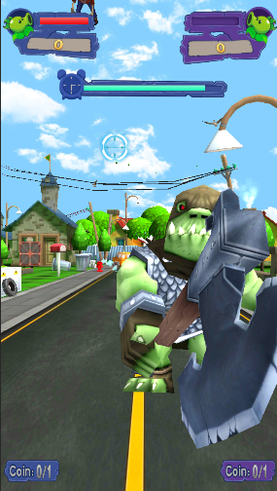

Zomby Interface Definition

Power 12V
Setting IN5 IN6 IN7
1P Fire IN4, Guncard 1P fire
2P Fire IN10, Guncard 2P fire
1P Switch Gun IN8, Guncard 1P switch gun
2P Switch Gun IN11, Guncard 2P switch gun
1P Insert Coin IN13，IN2
2P Insert Coin IN14
1P Gift Machine Signal IN17
2P Gift Machine Signal IN18
1P Gift Machine Motor Out1
2P Gift Machine Motor Out2
Loudspeaker Speaker
Gun PCB Card USB1

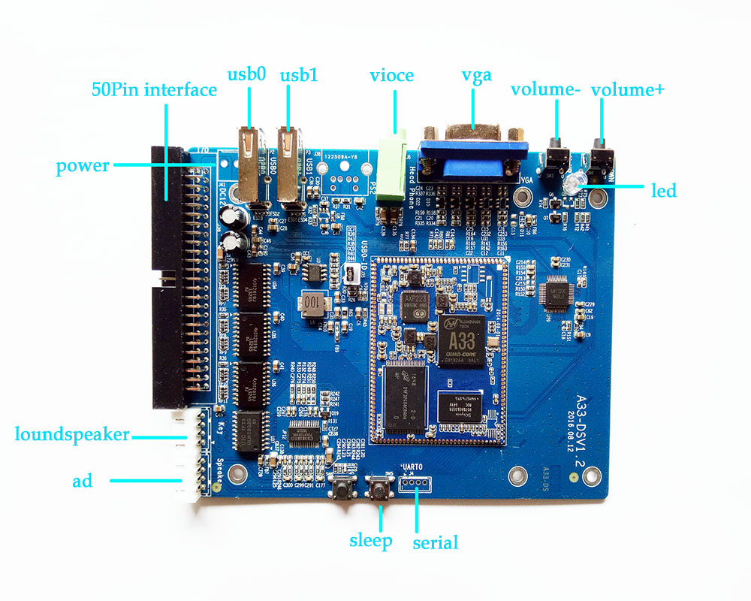
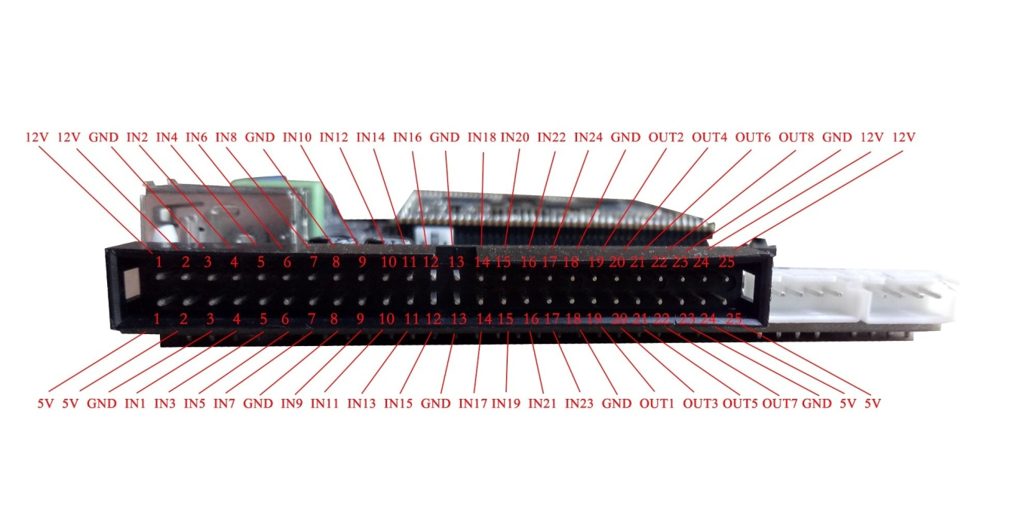

Gun Card Interface Definition


