ICE CREAM PARADISE INSTRUCTION SHEET

1. Enter Settings Menu
Locate test panel inside the front door of the machine.
To enter the settings menu press “UP and DOWN at the same time.

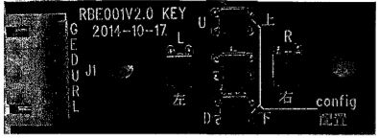

2. Settings Menu
Adjust settings by using the UP, DOWN, LEFT and RIGHT buttons.
Once you are happy with the adjustments, move the cursor to the “EXIT” then press the “OK” button.

3. Troubleshooting
a) Not Accepting Coins:
Check +12v and OV supply to coin acceptor.
Make sure that there are no broken or trapped wires.
Check coin mech rundown path for dirt/obstruction.
Reseat coin mech plug.

b) No Game:
Does monitor show “NO SIGNAL” (if Yes, monitor is ok)
Check for LED on Main Game Board (Blue)
Check for light on Power Supply Unit (test PSU for voltage)
Exchange suspected faulty part and retest.

When rebooting machine, please power down for 5 seconds to discharge any remaining voltage.
