Instructions of
DINO LAND/Ice cream paradise
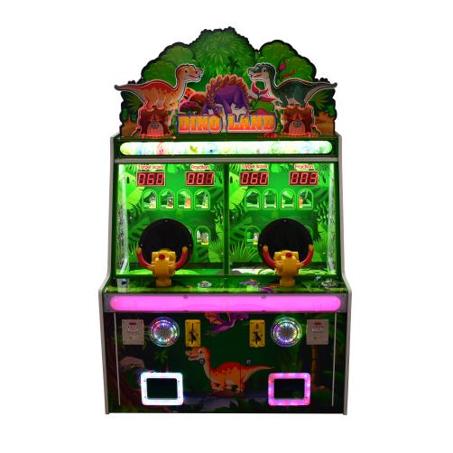
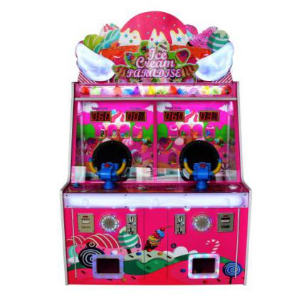

LIST
1. Specifications and technical parameters of the machine
2.Random accessories list
3.Game Description
4.Machine introduction
5.Common faults and Solutions
6.Parameter setting method

- Specifications and technical parameters of the machine

- working voltage：AC110V 60Hz—AC220V 50Hz
- Power consumption ：Min110W，Max：250W，Net weight：60KGS×3
- Shape size ：W1700×D920×H1100（mm）

- Random accessories list
order number | name | Model specification | Number | Picture
1 | Power cord | 10A/250V | 1
2 | Launch wheel |  | 2 | 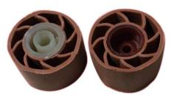
3 | key |  | 2
4 | Instructions | Chinese | 1
5 | Optical eye switch |  | 1 | 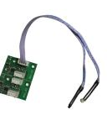
6 | Dinosaur doll |  | 1 | 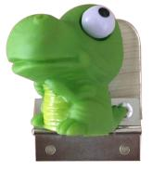

三、Game Description
- Insert coins
- Press the start button to start the game
- Press the launch button, the ball pops out, knocking down the front of the toy, each toy down = 1 points, the more knockout, the higher the score
- The game is divided into two points, the minimum score of the first pass requires 60 points to enter the second.
5.After the end of the game, the score exceeds the target points, and a reward gift/tickets.
This equipment is the product developed by our company from September 2016 to October 2017. It is deeply loved by the children at home and abroad.Characteristic ：
- unique appearance design, dazzling lighting effects
- Simple and fun gameplay, the game ends with toy, or lottery award
- the unique program has its own development, and the high quality electronic chip is selected, and the program is stable and efficient.
4.a variety of professional design, suitable for any style of playground and children's playground, choose the playground, the necessary facilities for the playground, can be placed in children's playground, supermarket, video game city, shopping mall and other venues.

四、Machine introduction

- the size and general of the whole machine

- the internal real picture and introduction of the whole machine

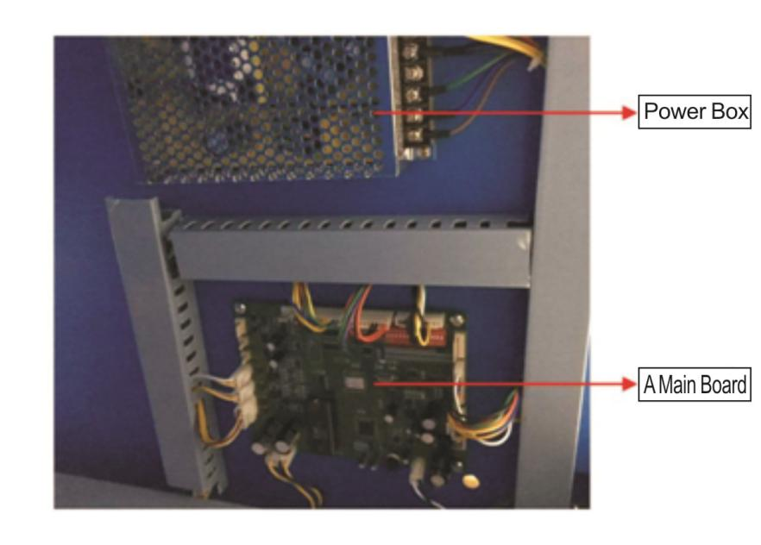

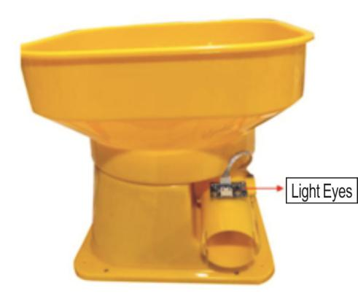 | 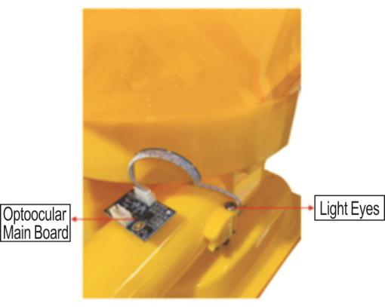
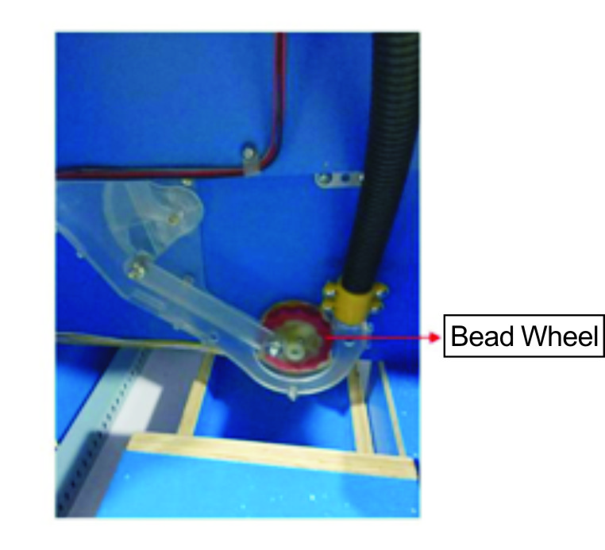 | 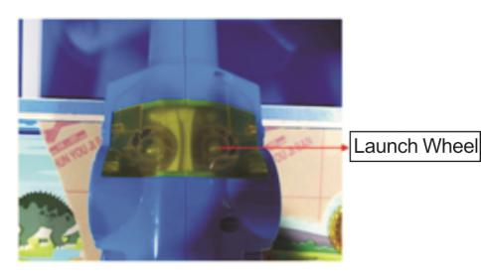
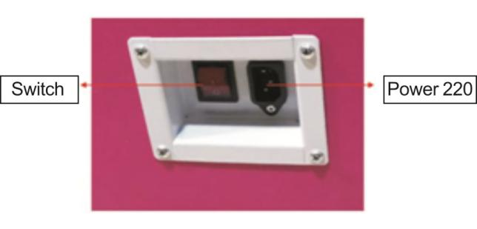

- .Common faults and Solutions

Failure phenomenon | Analysis | processing method
The whole machine is not working | - Power failure  - Damage of switch power box  3、Safety pipe damage | 1、Check the power supply voltage fault AC  2、+12 DC output, if there is no switch power box  3、Replacement of the insurance pipe
voice | - Trumpet bad  - The line of the horn is loosened  - Sound output problem, music chip  4、The back button of the main board is shut down | 1、Change the trump  2、Check line reconnection  3、Check the motherboard music chip, change  4、Turn the sound button on the main board to turn up the volume
Keep a Gashapon | - Light eye burn  - Main board burning | - Replacement  2、replacement
Not reacting to the coin | 1、The machine is loose or bad. | 1、check or replace
Gashapon do not come out | 1、Get stuck or broken | 1、Artificial exclusion, check or replace
Do not launch a bullet | - No bullet  - stuck  3、Launch wheel damage | 1、Fill  2、Check  3、replace
knockdown no score | 1、Scoring light bad | 1、replace
021 | - Lack Gashapon  2、Gashapon stuck | 1、fill  2、check
022 | Lottery failure | Check machine
Super Salvo common methods for troubleshooting
- false report
021：gashapon motor broken ，check the machine have any gashapon
022：lottery failure，check the machine have any gashapon

二、NO ball out
Check whether the line head is off, or whether there is something on the ball.
The ball can't pop up normally

三、The bullet launches a small force or can not be sent out. Check whether the launch wheel is damaged Please pay attention to the red right and change the left position of the white when replace.
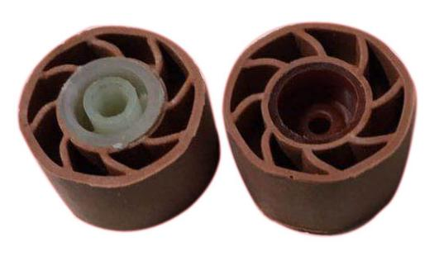

六、Parameter setting method

Open the back, find the key to open the stop on the motherboard
main board I/O
