In order to prevent the variety of problems which caused by incorrect operation, please read the manual first before operating this machine and pay attention to the items marked in “note”.
Please keep this manual carefully for checking when needed.

Summary
- Transportation, installation, safe operation of moving and operating methods and attentions;
- Installation and operation;
- Function adjustment;
- Maintenance;
- General troubleshooting and solutions;
- Main components diagram;
- Circuit connection diagram.


September 16th, 2013
Safety Attentions
- Certain part of the game is with high voltage. Adjust the game by technician. Do not open the game door unless maintenance or parts replacement is required.
- Please switch off the power before checking and maintenance.
- Please switch off the power before opening the game door.
- Fire extinguisher equipment must be nearby the game.

Installation
The game must be located properly to avoid damages.
Improper Locations:
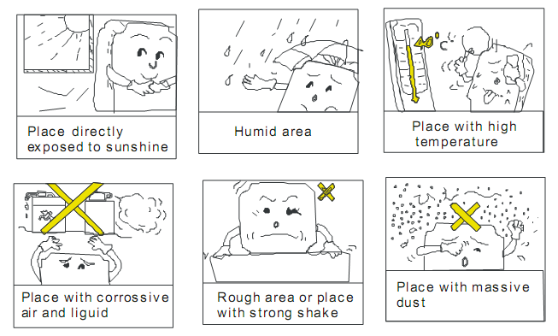

Notes of Usage
- The voltage range of the game should be 105V~115V or 215V~225V. The proper voltage should be 110V/220V. The specific voltage accords to the date plate on the back door of the game. The voltage must be correct; otherwise it would be difficult to repair the damage.
- The plug must be plugged in tightly and keep the power cords not be too tight and damaged in order to prevent bodily injury, short-circuit and power leakage.
- To put the machine to normal operating, please properly adjust the coin match and the game settings when use at the first time.
- Please regularly check all the functions of the game when operate to prevent dysfunction.
Notes of Maintenance
- Be sure to check and maintance the game regularly.
- Switch off the power before replacing the parts of the game.
- The parts for replacement should be the same model as the old one.
- Please check the connection and voltage output after replacing the power supply.
- The voltage range of the PCB should be 5.1V-5.4V.
- Check whether the game has creepage and the voltage before repairing the PCB.

Notes of Clean
- Please use clean and soft cloth to clean the game.
- Prevent damaging the surface of the game, please do not use the following cleanser:
- Alterative Cleanser；
- Acidic Cleanser；
- Insecticide, sterilized water, alcohol or other chemical cleanser.

Notes of Moving and Shipping
- Properly disassemble the game for necessary moving and shipping.
- Prevent the game from hitting or being attrite during movement.
- Protecting the case when move the game.

1. Game introduction
Kiddie Train with unique, beautiful and comic appearance, interesting and exciting game, it is specially designed and developed by our company for the young people. It will be very essential and popular in amusement center.

Features:
Realistic, colorful, cute outlook
Integrated main board, high-speed processing CPU, stable performances.
High definition, high-quality LCD display.
Coin mech with high quality fits for various coins.
Simple, stimulating, strong operational sense and full of entertaining.

2. Playing tips and Operations
Playing tips：
Insert coin(s) and press the green button after ride on the train.
Press steam whistle button on control panel, the train will make a steam whistle sound; press smoke button, the train on the display will blow smoke; press wiping button, the worker on display will stop shoveling coal to wipe their sweat; press acceleration button the worker add coal faster to accelerate, the train will move faster.

3. TECHNICAL PARAMETER
VOLTAGE: AC220V/110V（50/60HZ）
MAX. CURRENT: 6.5A/13A
(Note: please refer to the nameplate located on the back of the games to check actual usage of voltage.)
MAX. POWER: 1450W
STANDBY POWER: 230W
COIN SIZE：φ21mm ~ φ30mm (diameter)
1.2mm ~ 2.5mm (thickness)
CAPACITY OF COIN BOX: 2100pcs of coins with coin sizeφ25mm*1.5mm
LOCATION REQUIRED: -5 ~ 40℃, humidity is less than 90%. No contact with any corrosive liquid, no any greasiness and dirt.
DIMENSIONS: L2000mm*W1050mm*H1950mm
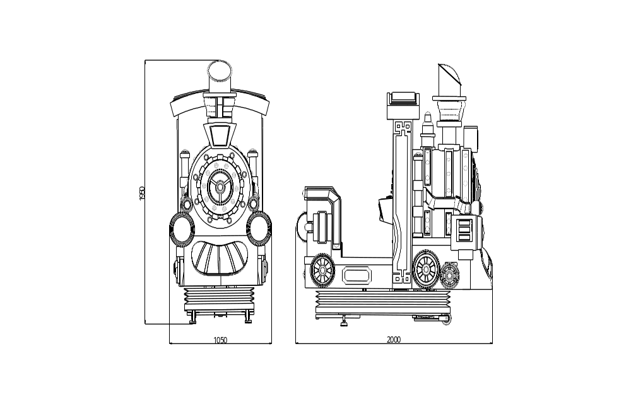

Parts shipped with the game:
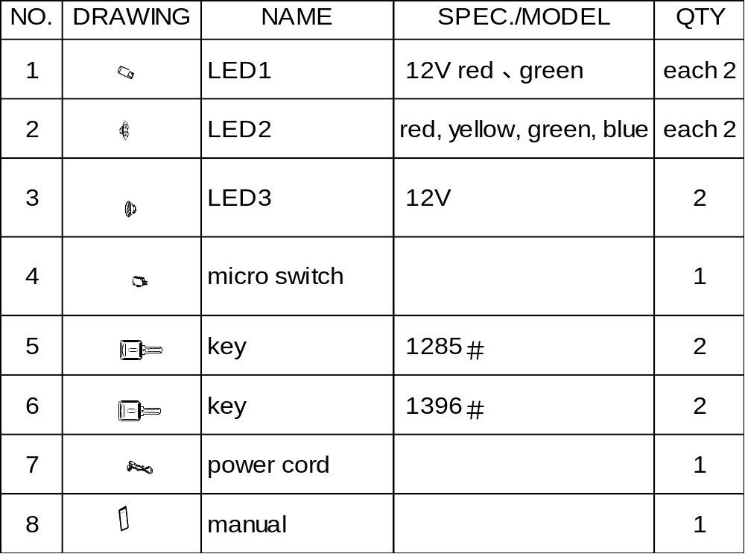

4. MOVEMENT
Direction of movement diagram:

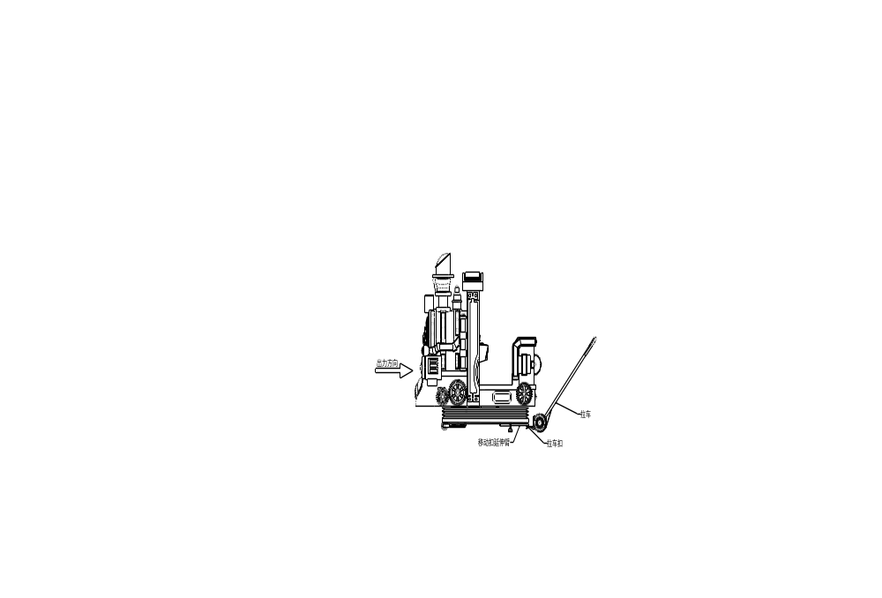

Note: when the road surface is uneven during moving or when you tilt the machine, please pay attention to the strength to prevent damage to the fiberglass body.

WARNING
- Please power off the game first and pull out the cord, then move the game.
- Please do not carefully move, turnover, transport the game; otherwise it will destroy the game.
- Prevent hitting, rubbing the games when move the games, otherwise it will damage the appearance of the game.

5. INSTALLATION
Please follow the direction below to install the game.

5.1 CHOOSE THE LOCATION FOR INSTALLATION
- Put the Kiddie Train in the same type of Kiddie Ride with monitor then select the concrete placement machine according to the machine's exterior.
- Choose the proper location for installation, please follow the below drawing to install.
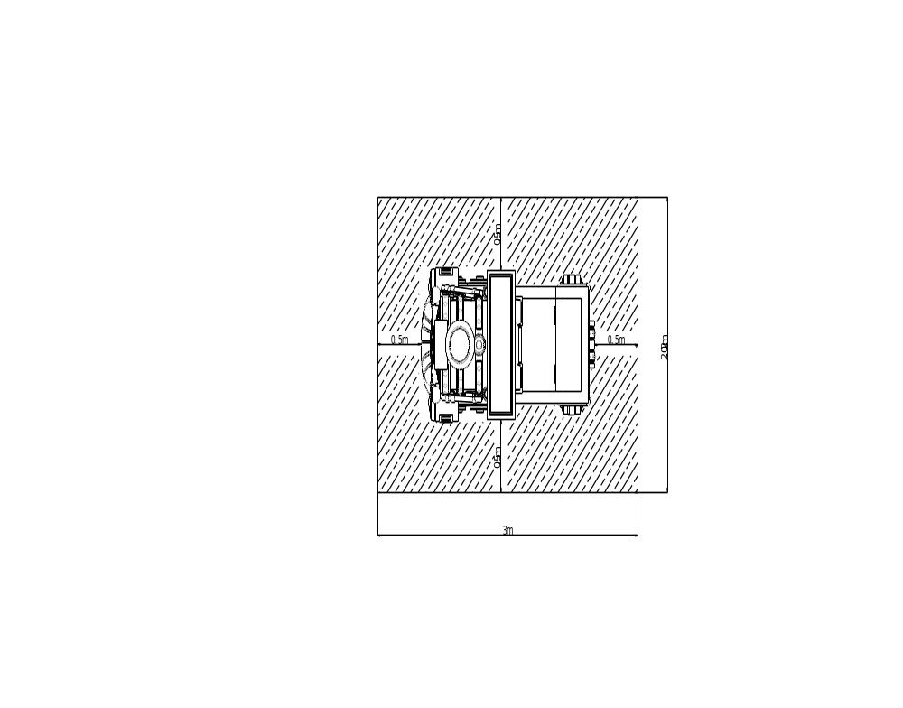

NOTE：It must be placed on the flat floor to make the machine on the ground steadily.

5.2 CHECK AND SET BEFORE CONNECTING THE POWER
- Please check whether the parts of cabinet are loose caused by moving, and the wire terminal should not drop out from the port.
- Check whether the GND is connected.
- Please check whether the resistance of power input at the both ends for GND is more than 100 megohm.
- Adjust the coin machine and check if it can work properly.
- Connect the wires.
Attention
  - 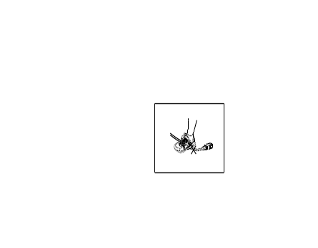Please make sure the power cord is not pressed by wheel, foundation, etc. Otherwise, it will damage the wire to cause short circuit, even fire. Do not use strong power to extend and wring the wires. Do not make the wire be near to the high temperature object. Properly put the wire to avoid any kicking or treading.
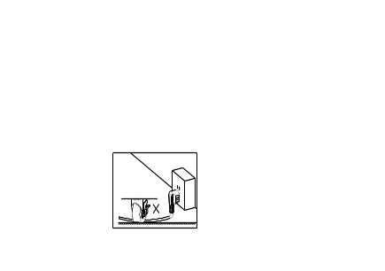

B. Hold the plug to pull it out from the socket. Do not touch the plug with wet hands.
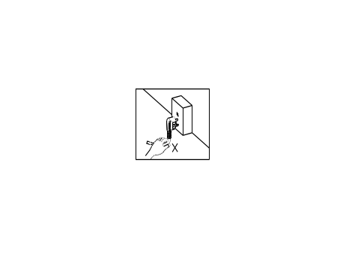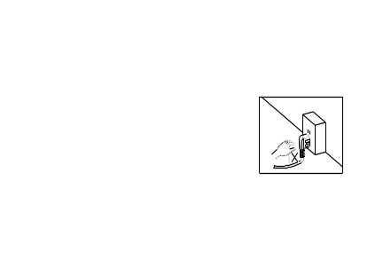

5.3 CHECK AND ADJUST AFTER CONNECTING THE POWER
- Make sure the input voltage is same as the one stated on name plate on the back door of the game.
- After connecting the power, please switch on the game.
- Inserting coin to check if the coin machine cans work properly.
- Visually check the game and confirm the display and light can work properly.
- Enter into the setting program and set the game settings (include coin, game time, game levels, etc.)
- Insert coin to play the game, confirm the operation of the direction and the machine movement is normal.
- Check the sound if it is ok.

6. CHECK BEFORE OPERATION
Check the game before operation to prevent the game from working improperly when operated.
Checking item：
- Check if the cord is securely plugged in and without defects.
- Check the location of game.
- Check if the game case is without defects or burrs.
- Check if the game without dirt and properly stuck on with marks

7. DAILY OPERATION

7.1 INPUT POWER TO OPERATE
- Turn on the machine power switch.
- Visually check the game and confirm the display can work properly.
- Check the sound if it is ok.
- Confirm the coin mech, control button and the machine movement is normal.
Warning：Before operation, please confirm all the items above are ok.

7.2 CHECK AFTER OPERATION
- Check the display of the game and confirm it is proper.
- Double check the coin mech, control button and the machine movement is normal; If it has any problems, please solve the problem as soon as possible.

7.3 COLLECT COINS AND KEEP RECORD
- Switch off the power and open the door of the coin box to take out the coins
- Open the door of the coin mech to keep a record of the coins’ quantity.

8、 GAME SETTING

8.1 KEYS FOR SETTING

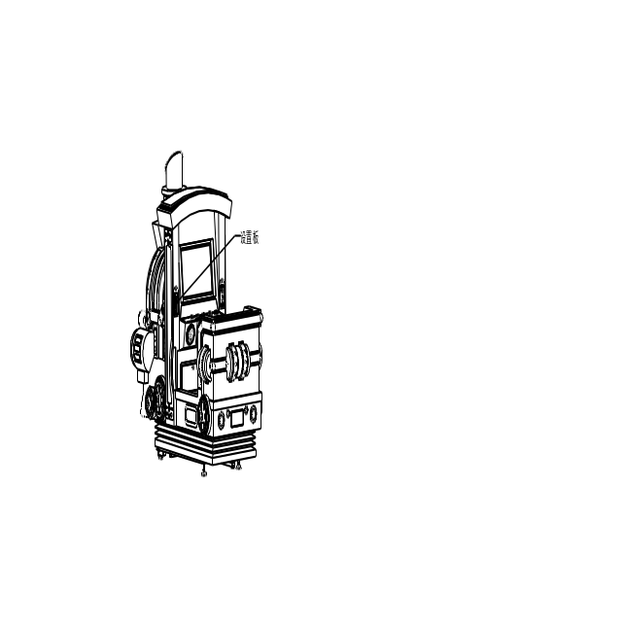

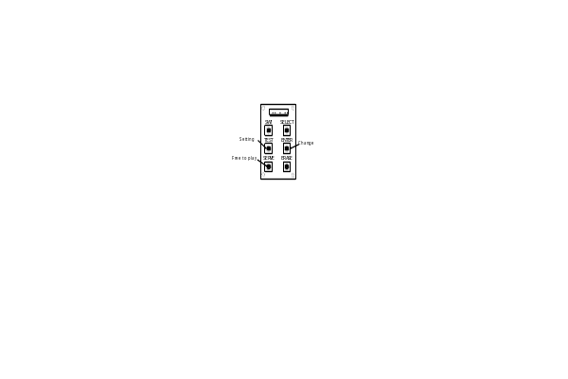

TEST: Enter into the setting menu or skip to the next menu.
ENTER: Change the setting.
SERVE: Free to play.

8.2 SETTING METHOD
Setting method: press “TEST” to enter into the game setting menu →press “ENTER” to change the setting → press “ENTER” exit setting.

8.3 SETTING DESCRIPTION
1）Game setting interface:
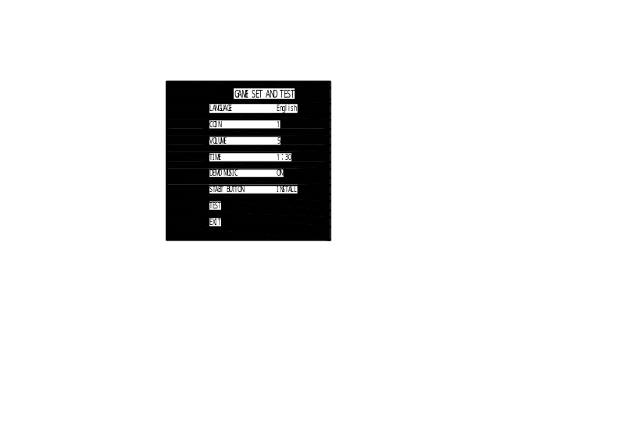

Descriptions:
Language: This setting decides which language will be displayed in screen, Chinese or English.
COIN：this setting can decide how many coins player should insert for one game. If set to “1”, it means insert 1 coin for 1 game.
VOLUME：this setting can decide the volume, if set to“5”, it is medium volume, the larger setting value, the larger volume.
TIME：this setting decides the limit time for one game. If set to “1:30”, it means has 1 and a half minus for one game.
DEMO MUSIC：this setting decides if play the demo music, if set to “ON”, then the game will play demo music when standby
START BUTTON：this setting decides if the player needs to press the start button. If set to “INSTALL”, then the player needs to press the start button.
TEST：this setting is for testing the buttons on control panel. Press the corresponding button, the screen will display OFF or ON.
EXIT：exit setting.
2）Testing interface:
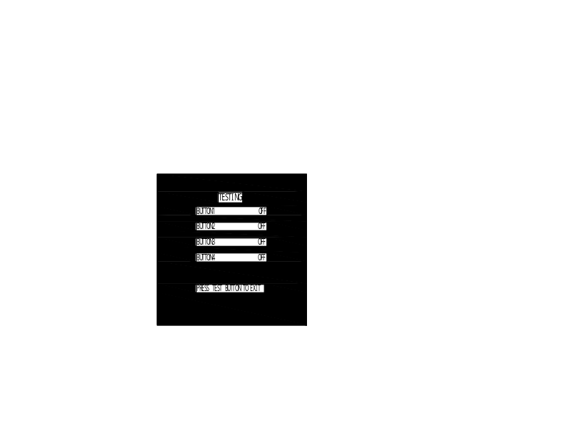

This interface is for testing the buttons on control panel. Press the corresponding button, the screen will display OFF or ON.

9. ADJUSTMENT

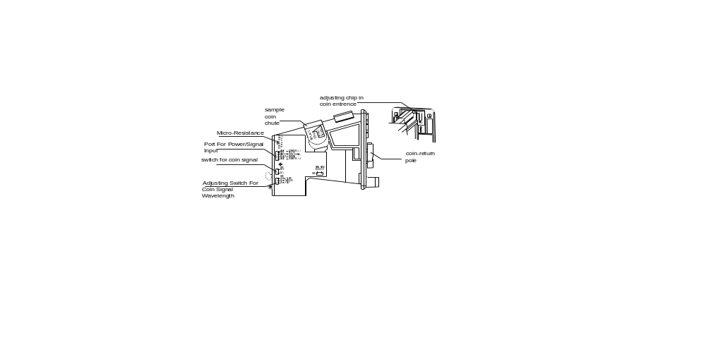9.1 ADJUT THE COIN MECH

Descriptions:
1): Please take out the plastic coin from sample coin chute and replace it with token.
2): Remove the screws on back of coin entrance. Adjust the fixing chip on back of coin entrance according to the token’s diameter, which prevent blocking the coin mech as inserting the large coin in by mistake.
3): Turn the COIN Switch to “NO” (COIN Signal wire and GND should be disconnected at usual time). Turning switch can be used as the coin mech switch when the game is power on.
4): Adjust the adjusting switch of COIN Signal wave length to 50MS.
- 5): Adjust the micro-adjusting resistance of token tolerance. Clockwise: increasing the sensitivity of token tolerance, that is, the range of accepting the token tolerance will be larger. Counter clockwise: decrease the sensitivity, that is, the range will be smaller and choose the token more strictly.

9.2 MAIN BOARD ADJUSTMENT

Diagram of main board:
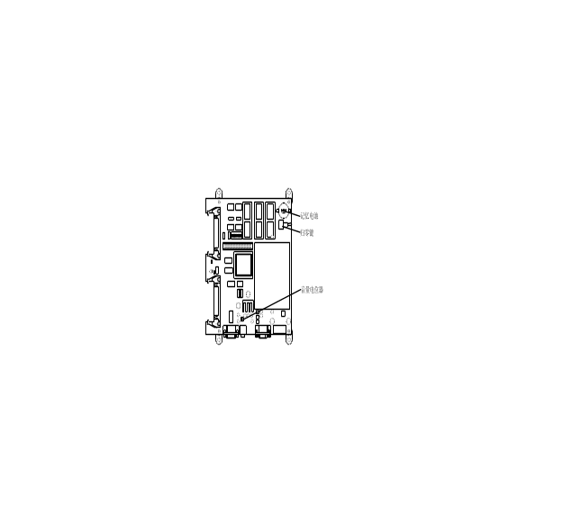

Descriptions:
Annulling Button: pressing this button can set the Game Setting to default and clear the data of Coin and Ticket saved in PCB.

Volume Adjustment: Use a flat screwdriver to twist the volume potentiometer to adjust the volume level of the machine. Turning clockwise will increase the volume; counterclockwise will decrease the volume.

！warning
The battery can save the data of game settings and coin number when the power off. Please replace the battery when the machine can not save the game setting.

10. CHECK AND MAINTAIN

！warning
Please check and maintain the game by technicians.
Please power off the game when check and maintain.
Please do not put any tools into cabinet, otherwise it will cause problem.
After checking, please tightly screw the screws and close the door.

10.1 Daily Check
ITEM | DESCRIPTION
Coin mech | Check whether the coin mech can work proper.
Start button | Check whether the button work normally.
Control button | Check whether the button work normally.
Motion | Check whether the motion is proper
Sound | Check whether the sound and the volume are ok.
Display | Check if the displayed colors are proper.
Temperature、humidity | Check if the temperature and humidity is proper

10.2 Daily Maintenance
ITEM | DESCRIPTION
Cabinet | Clean the cabinet with water and soft paper.
Monitor | Clean the ABS for monitor with water and soft paper.
PCB | Sweep the dust and dirty in the board with small brush

11. TROUBLESHOOTING
If you have any problem in installing or using the machine, we recommend that you first check the following table for possible cause of the problem and solution before asking for technical support:


