Guangzhou Unique Animation Technology Co., Ltd.

CRANE MACHINE
OPERATING INSTRUCTIONS

Please check the power source, crane, motherboard, wire and so on to confirm whether they fall off or loose in the transport process before starting. After confirming no mistakes and then start it. When starting up is completed, the LCD console will display as follows:
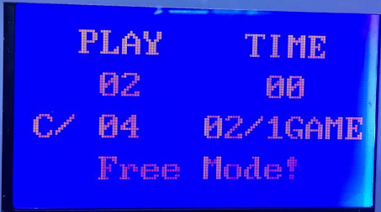
At the power switch beside the slot, press the red button"SETTING BUTTON " to enter the settings. The LCD will display as follows:
Move the rocker to control the cursor up and down, “OK BUTTON” to entry, operates the rocker to change each parameter,“OK BUTTON” to determine.
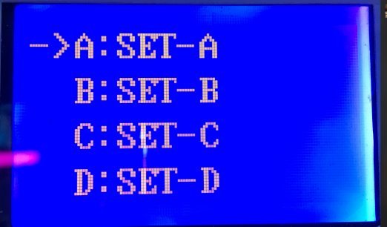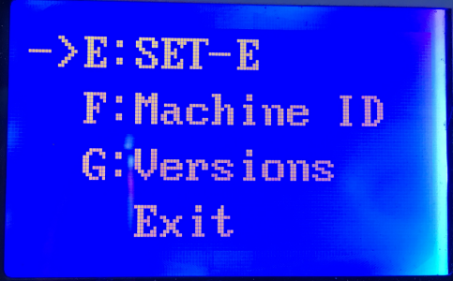
A:SET-A Key Adjustments (The following parameters are adjusted according to the actual situation)
A : Award mode(Fixation/random,choose Fixation)
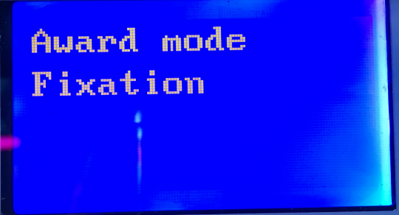
B : Game coin(How many coins for one game)
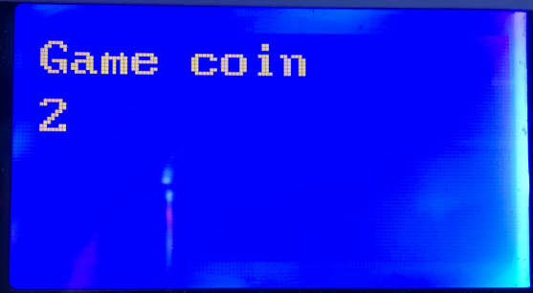
C：Free mode ( OFF)
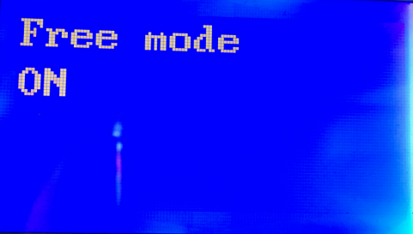
D：EP Ensure protection times/probability( 0 means that when the winning claws stress is coming,the player only get one chance to win and then renew the winning probability. 1 means that when the winning claws stress is coming,if the player failed because of mistakes,it can give the player one more chance to win in next game and then renew the winning probability, and so on.)

E : Ensure protection coin(YES/NO)
F : Playtime ( 20 )
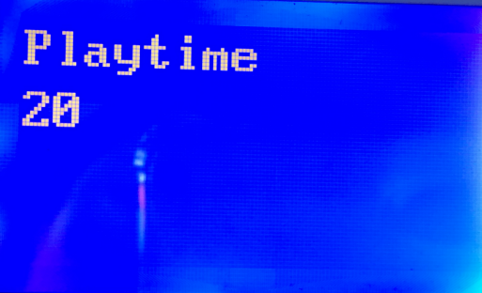
G : Amount
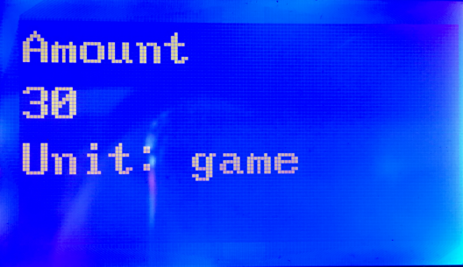
H : Accounts
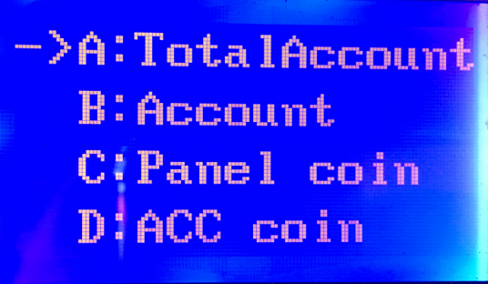
A：Tatal account B：Account C：Panel coin D：ACC coin E：Total Donate F:Donate G:Integral
I：Clear
A：Account CLR（YES/NO）
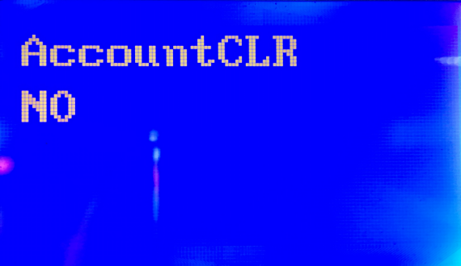
B：Coin CLR（YES/NO）
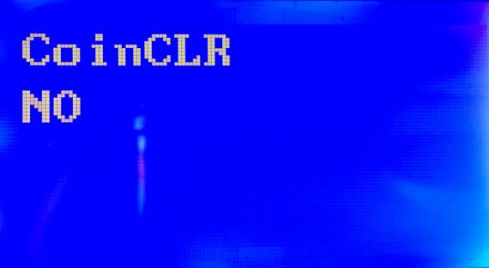
C：Reserve (Convenient to add other functions later)
J:ET K:Reserve Return
B:SET-B Crane adjustment（The following parameters are adjusted according to the actual situation）
A : Y speed-Forward and backward speed (Default Setting 60: the larger the value, the faster the speed)
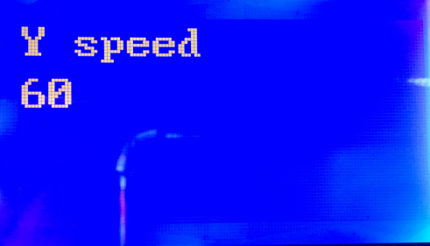
B：X-speed Leftward and rightward speed (Default Setting 65: the larger the value, the faster the speed)
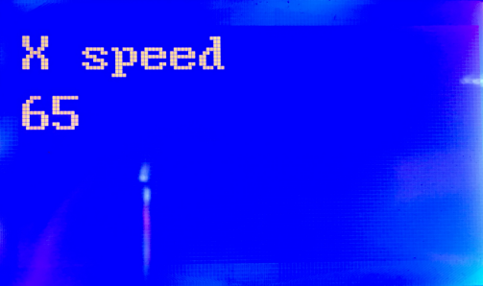

C:Z-speed Upward and downward speed (Default Setting 98: the larger the value, the faster the speed)
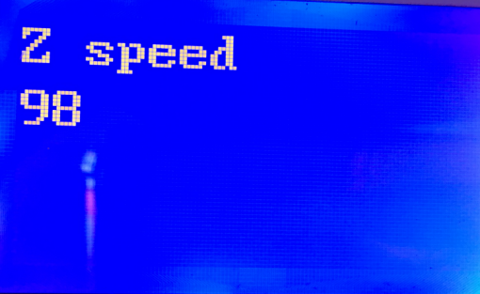
D:Z-length Upward and downward route（Default Setting 1600：length of setting-out the crane )
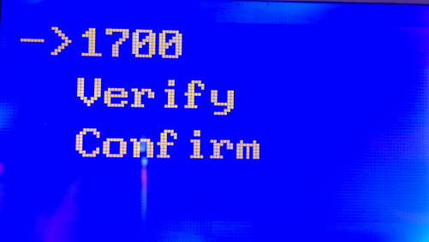
E：X-length Leftward and rightward route（Default Setting：Middle crane machine 3000 Mini big crane 2500 Mini small crane 2000）
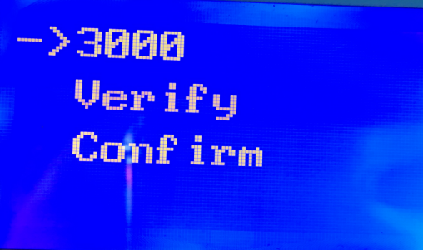
F、G：Reserve ( Convenient to add other functions later ) Return
C:SET-C Claw stress adjustment（The following parameters are adjusted according to the actual situation）

A：Stress Max-Award stress(The claw grip tightly)Standard is 45 V.
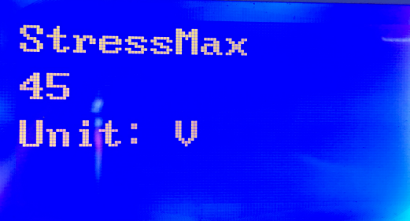
B：Stress 01(The stress for griping the toys up but not tightly)Standard is 35 V.
C：Stress 02(The stress for throwing away toys in the crane moving process)Standard is 15 V.
D：Stress 03(Ensure the claw can throw away the toys)Standard is 10 V.
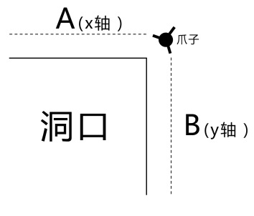
E：Position(Set the hole protection function to limit the translation falling objects）
A：Transverse moving distance（X axis1000）
B：Vertical moving distance （Y axis1200）
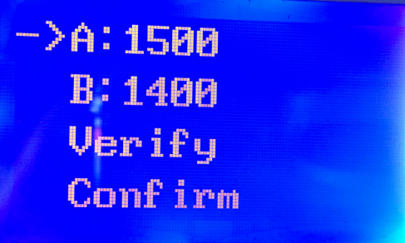
F:Delay- Translational release (The claw stress will be from strong to weak during the crane return journey after grabbing the gift)
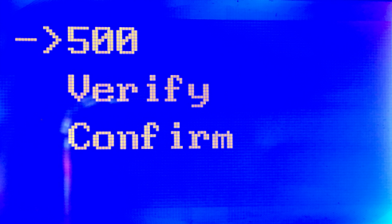
G： The claw stress change times(The times of the claw stress 02)
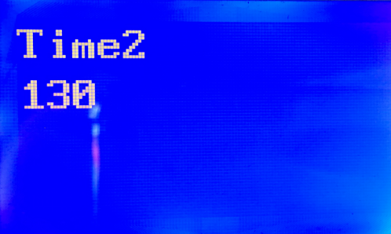
H：Randomly falling objects(The objects fall down on the top or Translating randomly)
I：Test claw(Through this function, You can check the limit drop point of the crane, where to set it, and whether the claw stress setting is reasonable)
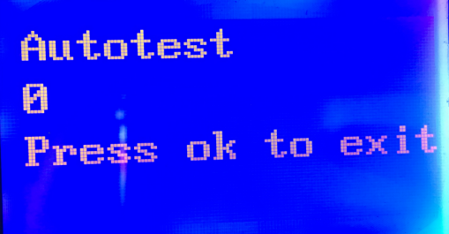
J：Reserve (Convenient to add other functions later)
K：Reserve (Convenient to add other functions later)

D：TEST-D Test（The following parameters are adjusted according to the actual situation）

A：Auto test（The number increases according to the tests times）
B：Photo Eye (Gift Sensor)
C：YF Sensor (Front fretting)
D：YB Sensor (Rear fretting)

E：XL Sensor (Left fretting)
F：2U Sensor(Up fretting)
G：2D Sensor(Down fretting)
H：Z-Motor Up and down button（Use the rocker to control）
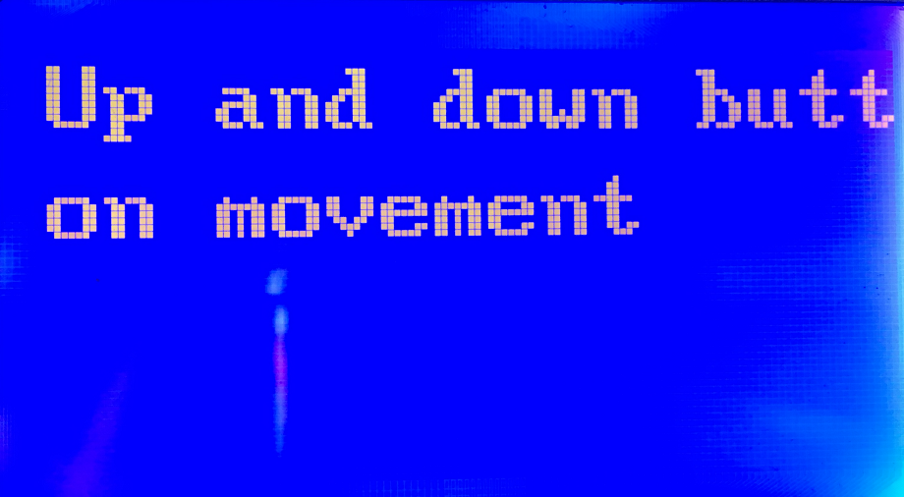
I：Y-Motor Front and back button（Use the rocker to control）
J：X-Motor Left and right button（Use the rocker to control）
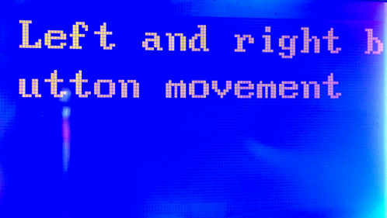
K：Reserve (Convenient to add other functions later)
E：SET-E Others adjustment(The following parameters are adjusted according to the actual situation)
A：Voice(Vocal settings)
A：Music（ON/OFF）

B：Voice（ON/OFF）
C：Music volume
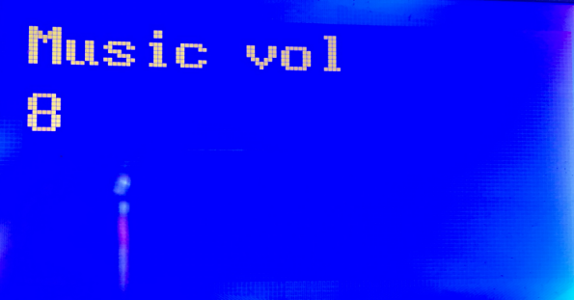
D：Voice volume
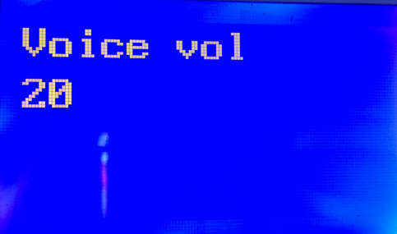
E：Idle music （ON/OFF）
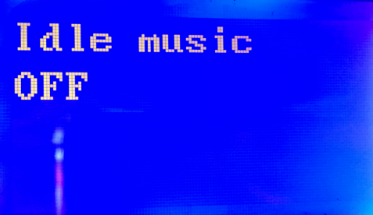
F：Idle voice（ON/OFF）
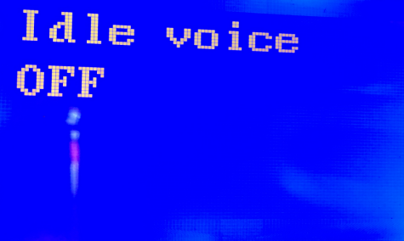
G：Award volume（25）
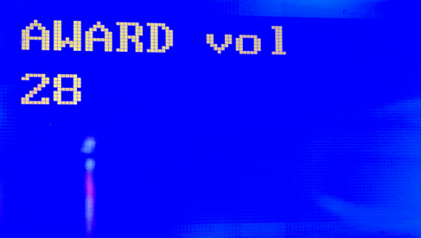
H：Music loop（ON/OFF）
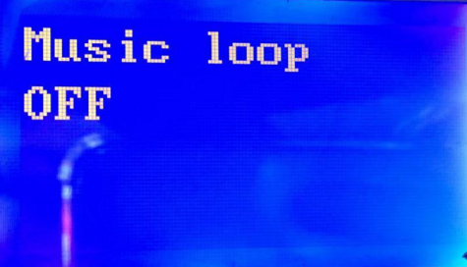
I：Reserve J：Reserve K：Reserve (Convenient to add other functions later) B：Selling mode
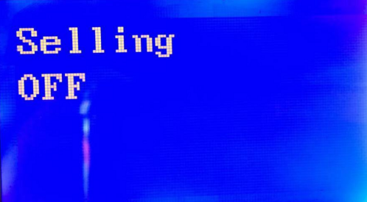
C：Air grip
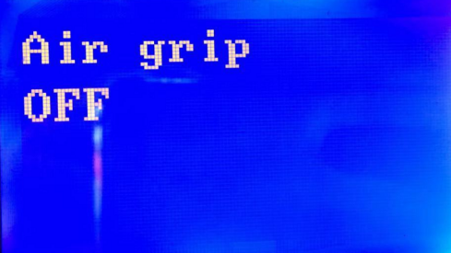
D：Advertisement roll
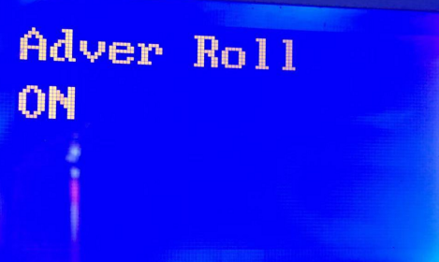
E：Pay
F：Exit position(Gift exit position)
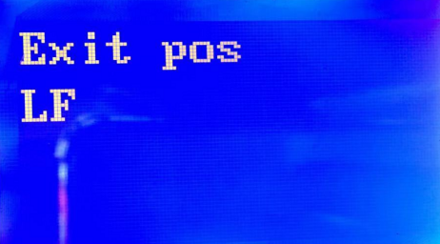

G：Intergration(change gift)
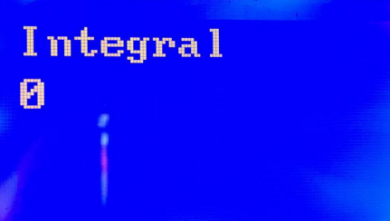
H：Z-Reverse (Upper and lower motor reverse)
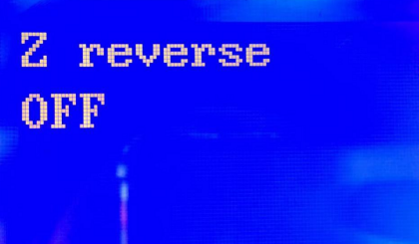
I:Rocker En J:Rocker Delay K:Rocker Time L:Factory Rst
M:Language N:System Set O:Photo Eye Return
F:SET-F Machine ID
G:SET-G Versions
Key adjustments(The following parameters are adjusted according to the actual situation)
1.Ensure protection times(Win Probability):0 means that when the winning claws stress is coming,the player only get one chance to win and then renew the winning probability. 1 means that when the winning claws stress is coming,if the player failed because of mistakes,it can give the player one more chance to win and then renew the winning probability, and so on.) 2.Ensure protection coin(YES):Whether need to insert the coins for next play time.
3.Claw force (stress)：
①Award-winning stress(45),The crane catch tightly as the standard;
②Stress 01(35),The claw stress can catch the objects up but not tightly as the standard;
③Stress 02(15),The claw stress can put down or throw away the objects as the standard；
④Stress 03(10),The claws close and back to the starting corner as the standard.
4.Randomly fall objects:When this function is turned on, the objects will be moved to the top first and then fall down in the translating process randomly within the limited drop area that you set before.When this function is turned off, the fallen trajectory of the objects according to the translation and limited drop area cooperatively.
5.Translation release the objects:When the function is turned on, the larger the data , the farther the distance after grabbing objects. It is generally recommended that the time of translation release is 500.
6.Limited drop point: Limited drop point parameter is set to form translation limit point in two directions of the hole so as to make objects fallen in the moving process and avoid falling into the hole. A parameter refers to the X axis of the crane to the right, and B parameter refers to the Y axis of the crane to the back. The bigger the parameters, the bigger the protected area, the higher the safety, the smaller the protected area, and the stronger the stimulation,the higher the sense of experience, it also means the fault rate. Generally, it is suggested that the parameters A and B should be set up. After checking, the distance between the crane and the hole is 12 centimeters in both directions. (This setting is related to the speed of the crane.)
7.Test claws：After testing the machine, you can use this function to test the situation of the limited drop point and grab the objects in different locations.
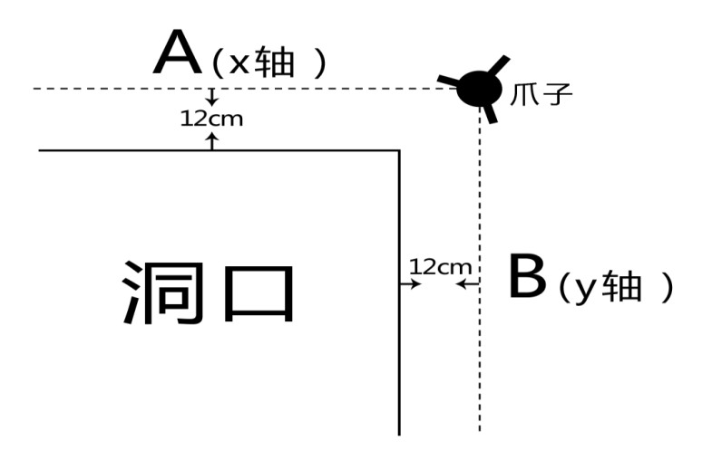

Simple troubleshooting

Problems | treatment
Memory failure | 1.Restore factory settings.  2. Check U9 memory chip.
Coin selector failure | 1.The motherboard defaults the coin selector is opened, check whether the coin selector is regular or not.  2. Background’s coin selector set to be open or closed regularly.It must be in accordance with the coin selector.
Gift light eye failture | 1. Check if gifts are not taken out.  2.Adjust the light Eye Distance.
Machine shaking failure | 1.Check the anti-rocker.
Front and rear motor fault | 1.Enter the background test item,check the Front and rear fretting .  2.Enter the background test item,check the front and rear motors.
Left and right motor fault | 1.Enter the background test item,check the left and right fretting .  2.Enter the background test item,check the left and right motors.
Up and down motor fault | 1.Enter the background test item,check the up and down fretting .  2.Enter the background test item,check the up and down motors.  3. Check the reverse setting of the up and down motors in the background, default is turn off.

